FINAL TECHNICAL REPORT

NUÑEZ RAMOS JOSE FRANCISCO

QUINTERO RAMOS SANTIAGO GABRIEL

SOLIS MOREIRA KEVIN JOSE

SUAREZ SOLORZANO MELANIE NICOLLE

VILLAROEL ESCOBAR MARCO SEBASTIAN

INSTALACIONES

Table of contents

1. General background and Project characteristics 5

2. Chapter 1: Drinking water system 6

*2.1* *Domestic water supply* 6

***2.1.1 Description*** 6

*2.2 Design criteria* 7

***2.2.1 Velocity*** 7

***2.2.2 Pressure*** 7

***2.2.3 Storage tank*** 7

***2.2.4. Main pipes*** 8

*2.3 Water supply and instantaneous flow* 8

***2.3.1 Water supply system*** 8

***2.3.2 Estimation of the instantaneous flows*** 9

***2.3.3 Calculation of the probable maximum flow rate*** 10

***2.3.4 Calculation of diameter of the water supply pipe to the house.*** 11

*2.4 Water storage* 11

***2.4.1 Tank sizing*** 11

*2.5) Water distribution* 12

*2.6 Pumping systems* 18

*2.7 Technical specifications: Drinking water systems* 19

***2.7.1***  ***Piping*** 26

***2.7.2 Fittings (Elbows, tees, whys and reducers)*** 27

***2.7.3 Valves (Breakdown in all their types)*** 30

***2.7.4. Pumps*** 31

*2.2* *Sanitary drainage system* 32

***3.1.1 Description*** 32

***3.1.3 Diameter of horizontal branches*** 36

***3.1.4 Ventilation systems*** 38

*3.2 Technical specifications: Sanitary drainage system* 39

3. Chapter 3: Storm water drainage system 48

*4.1 Storm water drainage system* 48

***4.1.1) Diameter of downspouts/downpipes*** 48

***4.1.2 Diameter of horizontal branches*** 49

*4.2 Technical specifications: Storm water drainage system* 50

4. Chapter 4: Electrical system 54

*5.1 Estimation of the electrical demand* 54

*5.2 Feeding system to transformer* 57

*5.3 Feeding to main panelboard (TDG)* 58

*5.4 Panelboards* 59

*5.5 Feeding to distribution panelboards* 59

*5.7 Grounding systems* 62

*5.8 Branch circuit schedules* 63

*5.9 Branch circuit schedules* 64

***5.9.1 Codes and standards used.*** 64

***5.9.2 Materials*** 64

***5.9.2.1 Pipes*** 64

***5.9.2.2 Junction boxes*** 65

***5.9.2.3 Wire*** 66

***5.9.2.4 Panelboards*** 66

***5.9.2.5 Distribution panels*** 67

***5.9.2.6 Circuit breakers*** 68

***5.9.2.7 Switches and outlets*** 69

***5.9.2.8 Transformers*** 69

5. Analysis of alternatives 70

6. Recommendation and conclusions 70

7. References 70

8. Appendix 70

List of Figures

*Figure 1. Residence. Urbanization “Ciudad Celeste” - Stage “Estribor” 5*

*Figure 2. Indirect System using a cistern to pumping water. 6*

*Figure 3. Temperatures and water consumption in sanitary cases. NEC-2011 7*

*Figure 4. Table 16.1. Flow rates, pressures, and diameters requirements in consumer appliances (NEC-11) 9*

*Figure 5. Architectural plan view for the cistern. 12*

*Figure 6.Grown floor layput 16*

*Figure 7. Isometric view 17*

*Figure 8. Upper floor layout. 17*

*Figure 9. Pedrollo’s curves for pump. 19*

*Figure 10. PK60-MD Model pump 19*

*Figure 11. Design of the drainage pipes 33*

*Figure 12. Flow rates per units. 37*

*Figure 13. Sections for the collectors in each floor 38*

*Figure 14. Diameter for ventilation systems. 38*

*Figure 15. Area to drain 49*

*Figure 16. Paper versión. Rainwater schemes 49*

*Figure 17. Ground floor – Electrical distribution 56*

*Figure 18. Upstairs – Electrical distribution 57*

*Figure 19. Distribution Transformers example 58*

*Figure 20. Panelboard distribution 59*

*Figure 21. “Unifilar” diagram 60*

*Figure 22. Branch circuits distribution 60*

*Figure 24. Electrical Distribution – Upstairs 63*

*Figure 23. Electrical Distribution – Ground Floor 63*

List of Tables

*Table 1. Estimation of instantaneous flow rates for first floor. Cold water. 9*

*Table 2. Estimation of instantaneous flow rates for first floor. Hot water. 10*

*Table 3. Estimation of instantaneous flow rates for second floor. Cold water. 10*

*Table 4. Estimation of instantaneous flow rates for first floor. Cold water. 10*

*Table 5. Dimensioning of the cistern with the demands of the house. 11*

*Table 6. Dimensions of cistern construction 11*

*Table 7. Instantaneous flow chart of the different hydro sanitary fixtures 13*

*Table 8. Instantaneous flow rates for first floor by sanitary appliance. Cold water 13*

*Table 9. Instantaneous flow rates for first floor by sanitary appliance. Hot water 14*

*Table 10. Instantaneous flow rates for second floor by sanitary appliance. Cold water 14*

*Table 11. Instantaneous flow rates for second floor by sanitary appliance. Hot water 14*

*Table 12. Piping for cold water 15*

*Table 13. Piping for hot water 15*

*Table 14. Units by accesory 34*

*Table 15. Discharge diameter limits 34*

*Table 16. Downspouts per floor. 35*

*Table 17. Diameter of downspouts by room. 36*

*Table 18. Diameter for vertical branches. 36*

*Table 19. Rainfall intensity 48*

*Table 20. Storm water downspouts 48*

*Table 21. Rainfall intensity by S % 49*

*Tabla 22. Dimensions of storm water collectors 50*

*Table 23. Monopolar Braker Capacity 61*

*Table 24. Bipolar Braker Capacity 61*

*Table 25. Aplications by breaker 61*

*Table 26. Materials for each component 64*

*Table 27. Value per unit of pipes 64*

# ***General background and Project characteristics***

The project is located on Samborondon, kilometer nine, in the Ciudad Celeste citadel. It is a house project of a living room, dining room, guest bathroom, kitchen, laundry, service room and bathroom, a big yard, three bedrooms with the respective bathroom and a garage.

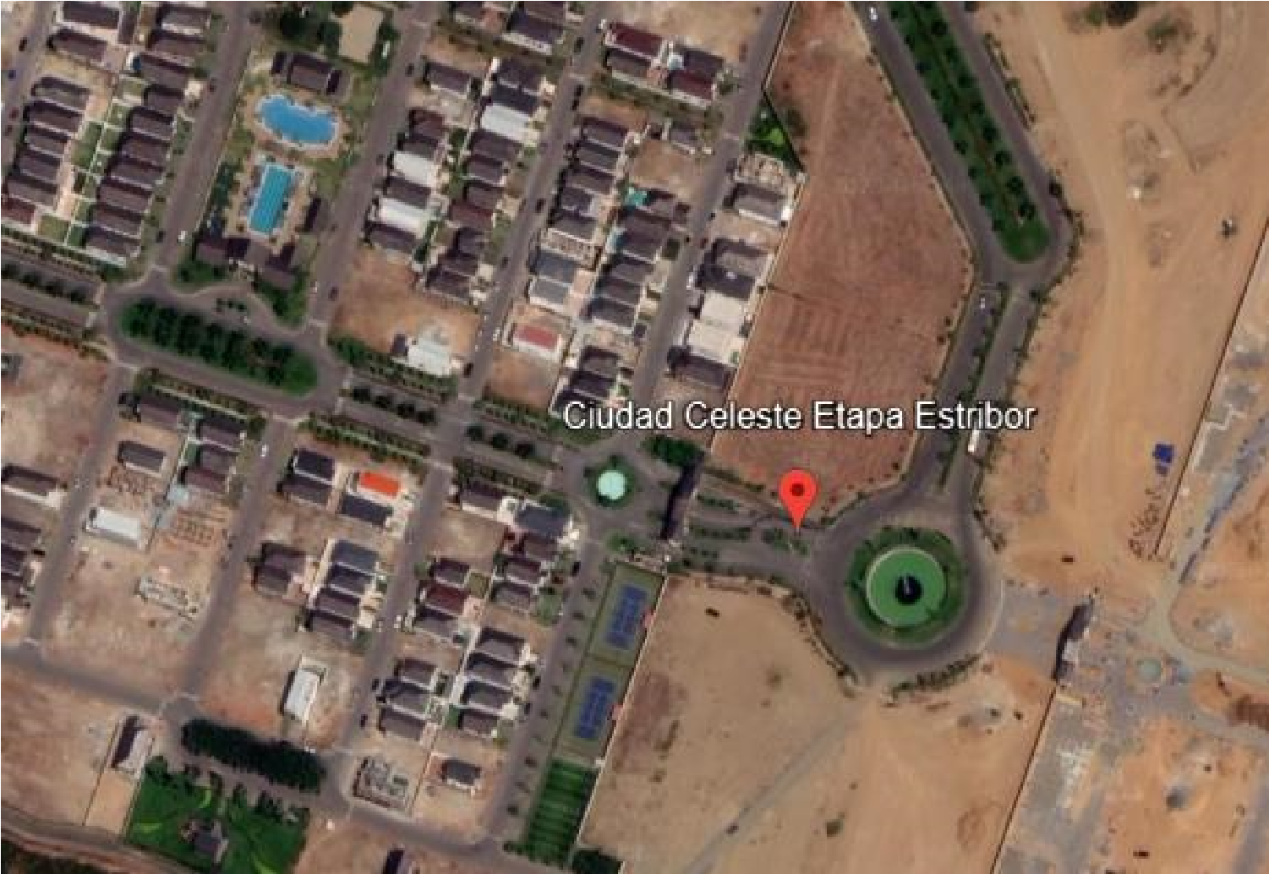

*Figure 1. Residence. Urbanization “Ciudad Celeste” - Stage “Estribor”*

|  |  |  |  |  |
| --- | --- | --- | --- | --- |
| Description | East | North | Latitude | Longitude |
| Point | 629167.9356251 | 9770147.272081 | -2.0791108° | -79.8385207° |

The following report details the sanitary hydraulic desing. This one includes:

* + Drinking Water Distribution System
  + Sewage Drainage System
  + Rainwater Drainage System

The design has been made by the architectural information found in the plans and using the Ecuadorian Construction Regulations (NEC-2011), NTC 3721 for Test Methods, NTC 3722 for Specifications and INEN 1374 Standards.

# ***Chapter 1: Drinking water system***

* 1. ***Domestic water supply***

### ***2.1.1 Description***

To get the design of the drinking water distribution you take a request using a water supply tank so, you need to use an indirect water supply system.

This system takes the water stored in a cistern from pumping, and it is pumped to all the water consumption points of the house to correctly supply the home. The public network does not reach the equipment directly to supply all the water consumption points.

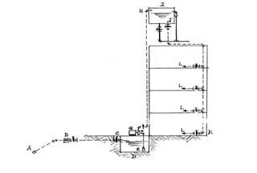

Figure 2. Indirect System using a cistern to pumping water.

It makes a big advantage because, usually in Samborondon, the water cut is applied to carry out maintenance works. This system allows the water supply to be maintained regardless of the water outage of the public network.

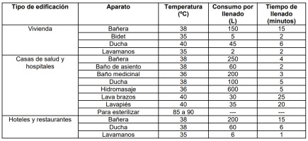Samborondon is a canton where people used to use the hot water supply. For that case, we need to know that:

Figure 3. Temperatures and water consumption in sanitary cases. NEC-2011

A hot water production system will be used taking it from a water heater. It needs to be automatic to supply all the points required from the house and also need an access for optimal ventilation. We need to carry out the gases produced by the equipment. High pressures.

The pumping equipment will be located down stairs in a store with free access from the yard. And we need to satisfy the maximum temperature demand, which is 40° C.

## ***2.2 Design criteria***

### ***2.2.1 Velocity***

According to the NEC, the speed criterion ranges between 0.6 m/s and 2.5 m/s, minimum and maximum respectively. However, the recommended speed criterion is 1.5 m/s so this is our optimal value considered.

### ***2.2.2 Pressure***

* + - A Pumping system with tank (high or low) would be required. It’s necessary to be provided.
    - The pressure must exceed 50 m.c.a in each node of the system, considering the residual pressure given by the equipment distributor.
    - By regulations, all installed pipes and equipment must withstand a pressure of 150 m.c.a. This value is considered the service pressure to avoid leaks or water hammer generated in the system.

### ***2.2.3 Storage tank***

* It is essential to have a storage tank, which has a useful volume corresponding to the consumption required in the building for the estimated 24-hour supply.
* The tanks must be designed and built in a way that guarantees the drinkability of the water during the reserve time and does not allow the entry of any type of contaminant.
* To control the filling of the tanks, a buoy or float or other "all or nothing" opening and closing device, solenoid valve, can be used.
* Downstream of every storage tank, a shut-off valve must be installed.
* No tank may have walls or floors that are absorbent or porous.
* The infrastructure that protects the warehouse must facilitate periodic cleaning.

### ***2.2.4. Main pipes***

* The pipe to the storage tank must supply the total daily consumption in a maximum time of 4 hours.
* The pipe connecting the low tank and the elevated tank must be independent from the rest of the distribution network; and its diameter must be calculated so that it can fill the elevated tank in a maximum of 2 hours.
* The use of tubes whose materials contain aluminum and lead is prohibited.

## ***2.3 Water supply and instantaneous flow***

### ***2.3.1 Water supply system***

The existing public network doesn’t meet the requirements for using a saddle clamp, because the diameter of the main pipe isn’t >=3 times the diameter of our water supply connection, so this connection will be done by using a tee.

The water supply pipe can be crafted using a variety of materials, such as: Galvanized steel and protected with anti-corrosive paint (NTE INEN 1045), the color is specified in the NTE INEN 440, PVC (according to NTE INEN 1372; 1373; y, 2497) or Polyethylene (according to NTE INEN 1744). Also, the water supply pipe shall have a nominal diameter greater than or equal to (1/2”).

The shut off valve must be located on the exterior of the property, on the service connection at the sidewalk or public road, in the front of the property. A quarter-turn valves will be considered at the design because the pipes have diameters less than 60 mm.

The water supply pipe is known as the hydraulic connection from the main shut-off valve to the household water meter. Its installation must allow the leaks control at its ends as well as inspection at changes in direction and fittings along its path. The material for the supply pipe can be: galvanized steel (GS, according to NTE INEN 2470), polypropylene (PP), chlorinated polyvinyl chloride (PVC-C), crosslinked polyethylene (PEX), polybutylene (PB), or polyvinyl chloride (PVC according to NTE INEN 1372, 1373, and 2497).

### ***2.3.2 Estimation of the instantaneous flows***

To calculate the maximum probable flow, we need to estimate the instantaneous flows according to the sanitary devices in the property. The instantaneous flows are estimated according to the NEC-11.

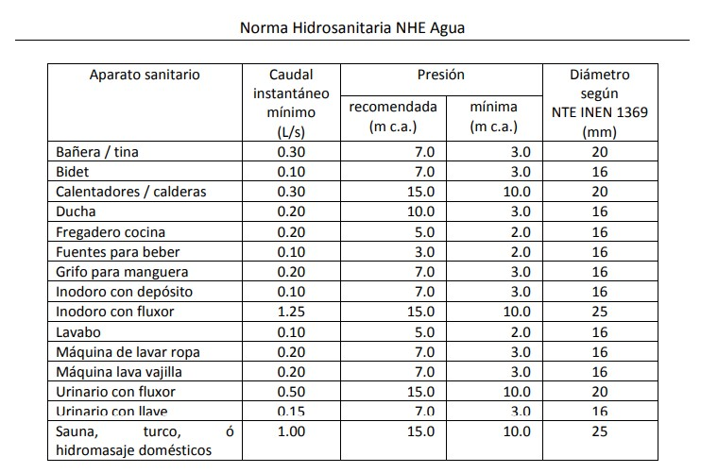

Figure 4. Table 16.1. Flow rates, pressures, and diameters requirements in consumer appliances (NEC-11)

***First Floor***

*(Cold Water)*

|  |  |  |  |
| --- | --- | --- | --- |
| **Amount** | **Sanitary Device** | **Min. Instantaneous Flow [l/s]** | **ΣMin. Instantaneous Flow [l/s]** |
| 2 | House Faucet | 0.2 | 0.4 |
| 2 | Toilet | 0.1 | 0.2 |
| 2 | Toilet sink | 0.1 | 0.2 |
| 1 | Shower | 0.2 | 0.2 |
| 1 | Kitchen sink | 0.2 | 0.2 |
| 1 | Laundry Machine | 0.2 | 0.2 |
| 1 | Water heater | 0.3 | 0.3 |

Table 1. Estimation of instantaneous flow rates for first floor. Cold water.

*(Hot Water)*

|  |  |  |  |
| --- | --- | --- | --- |
| **Amount** | **Sanitay Device** | **Min. Instantaneous Flow [l/s]** | **ΣMin. Instantaneous Flow [l/s]** |
| 2 | Toilet sink | 0.1 | 0.2 |
| 1 | Shower | 0.2 | 0.2 |
| 1 | Kitchen sink | 0.2 | 0.2 |
| 1 | Laundry Machine | 0.2 | 0.2 |

Table 2. Estimation of instantaneous flow rates for first floor. Hot water.

***Second Floor***

*(Cold Water)*

|  |  |  |  |
| --- | --- | --- | --- |
| **Amount** | **Sanitary Device** | **Min. Instantaneous Flow [l/s]** | **ΣMin. Instantaneous Flow [l/s]** |
| 3 | Shower | 0.2 | 0.6 |
| 3 | Toilet | 0.1 | 0.3 |
| 3 | Toilet sink | 0.1 | 0.3 |

Table 3. Estimation of instantaneous flow rates for second floor. Cold water.

*(Hot Water)*

|  |  |  |  |
| --- | --- | --- | --- |
| **Amount** | **Sanitary Device** | **Min. Instantaneous**  **Flow [l/s]** | **ΣMin. Instantaneous**  **Flow [l/s]** |
| 3 | Shower | 0.2 | 0.6 |
| 3 | Toilet sink | 0.1 | 0.3 |

Table 4. Estimation of instantaneous flow rates for first floor. Cold water.

### ***2.3.3 Calculation of the probable maximum flow rate***

The maximum probable flow rate (QMP) shall be calculated using equation 16-2 (NEC-11), and the simultaneity coefficient (kS) will be determined using equation 16-3 (NEC-11).

𝑄𝑀𝑃 = ∑𝑄𝑖 ∗ 𝑘𝑠 𝑘𝑠 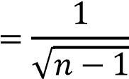

Recalling the data from the tables previously provided:

∑𝑄𝑖 = 4.60 𝑙/𝑠

𝑛 = 30 𝑠𝑎𝑛𝑖𝑡𝑎𝑟𝑦 𝑑𝑒𝑣𝑖𝑐𝑒𝑠 𝑘𝑠 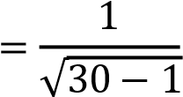

𝑘𝑠 = 0.19

𝑄𝑀𝑃 = 0.87 𝑙/𝑠

### ***2.3.4 Calculation of diameter of the water supply pipe to the house.***

Where v= 1.5 m/s and D= diameter of the pipe

𝐷 = 1 "

The 1 " is selected, but we need to ensure about the velocity.

The velocity stills in the range established by the NEC-11 [0.6 m/s < v < 2.5 m/s].

## ***2.4 Water storage***

### ***2.4.1 Tank sizing***

According to Table 16.2 of the NEC-11, the suggested endowment is 200 liters/inhabitants/day, and considering a house with 5 inhabitants and the storage time selected for the project will be 2 days, we will have a flow of 2000 L, assuming a height of 2 m with a free edge, we obtain the following dimensioning:

|  |  |  |
| --- | --- | --- |
| **Cistern design** | |  |
| **Water Volumen** | 2 | m3 |
| **Free Height** | 0,3 | m |
| **H Height** | 1,5 | m |
| **H Total** | 1,8 | m |
| **L** | 1,2 | m |

*Table 5. Dimensioning of the cistern with the demands of the house.*

|  |  |  |
| --- | --- | --- |
| **Final tank measurements** | | |
| **H** | 1,8 | m |
| **L1** | 1,5 | m |
| **L1** | 1,5 | m |
| **Total Volume** | 4,05 | m3 |

Table 6. Dimensions of cistern construction

On the building plan, we can see the location of the water tank (cistern) by the cyan color, with its respective measurements.

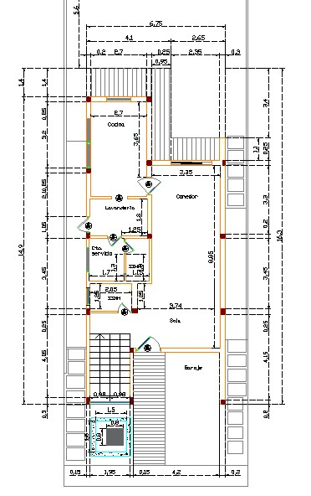

Figure 5. Architectural plan view for the cistern.

The tank filling control will be through a float, downstream of the tank, a filter will also be installed, and the walls of the tank will be waterproofed to prevent deterioration in water quality.

Access to the warehouse will be 0.8 m x 0.8 m.

Maintenance should be performed at least once a year on the tank.

## ***2.5) Water distribution***

The instantaneous flow table was used to calculate the flow rate:

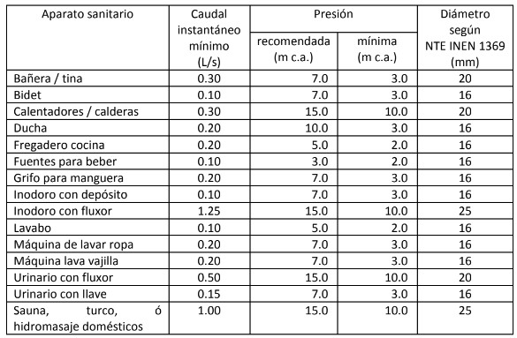

Table 7. Instantaneous flow chart of the different hydro sanitary fixtures

For this system, the pump will be in a place where it will be supplied with water from the cistern and will distribute cold water to all the faucets we have, even the water heater. Then, it will provide hot water to the different faucets throughout the house required.

**INSTANTANEOUS FLOW RATES**

***First Floor***

*(Cold Water)*

|  |  |  |  |
| --- | --- | --- | --- |
| **Amount** | **Sanitary Device** | **Min. Instantaneous** **Flow [l/s]** | **ΣMin. Instantaneous** **Flow [l/s]** |
| 2 | House Faucet | 0.2 | 0.4 |
| 2 | Toilet | 0.1 | 0.2 |
| 2 | Toilet sink | 0.1 | 0.2 |
| 1 | Shower | 0.2 | 0.2 |
| 1 | Kitchen sink | 0.2 | 0.2 |
| 1 | Laundry Machine | 0.2 | 0.2 |
| 1 | Water heater | 0.3 | 0.3 |

Table 8. Instantaneous flow rates for first floor by sanitary appliance. Cold water

*(Hot Water)*

|  |  |  |  |
| --- | --- | --- | --- |
| **Amount** | **Sanitay Device** | **Min. Instantaneous** **Flow [l/s]** | **ΣMin. Instantaneous** **Flow [l/s]** |
| 2 | Toilet sink | 0.1 | 0.2 |
| 1 | Shower | 0.2 | 0.2 |
| 1 | Kitchen sink | 0.2 | 0.2 |
| 1 | Laundry Machine | 0.2 | 0.2 |

Table 9. Instantaneous flow rates for first floor by sanitary appliance. Hot water

***Second Floor***

*(Cold Water)*

|  |  |  |  |
| --- | --- | --- | --- |
| **Amount** | **Sanitary Device** | **Min. Instantaneous** **Flow [l/s]** | **ΣMin. Instantaneous** **Flow [l/s]** |
| 3 | Shower | 0.2 | 0.6 |
| 3 | Toilet | 0.1 | 0.3 |
| 3 | Toilet sink | 0.1 | 0.3 |

Table 10. Instantaneous flow rates for second floor by sanitary appliance. Cold water

*(Hot Water)*

|  |  |  |  |
| --- | --- | --- | --- |
| **Amount** | **Sanitary Device** | **Min. Instantaneous**  **Flow [l/s]** | **ΣMin. Instantaneous**  **Flow [l/s]** |
| 3 | Shower | 0.2 | 0.6 |
| 3 | Toilet sink | 0.1 | 0.3 |

Table 11. Instantaneous flow rates for second floor by sanitary appliance. Hot water

**PIPING**

***Cold water pipes:***

|  |  |  |  |  |  |  |
| --- | --- | --- | --- | --- | --- | --- |
|  |  |  | **Cold water** |  |  |  |
| **Section** | **Qi (L/s)** | **s** | **Ks** | **QMP (L/s)** | **D (mm)** | **Pipe Size** |
| 1-2 | 0.2 | 2 | 1 | 0.20 | 13.03 | 1/2'' |
| 2-3 | 0.3 | 2 | 1 | 0.30 | 15.96 | 1/2'' |
| 3-4 | 0.4 | 3 | 0.707 | 0.28 | 18.43 | 1/2'' |
| 4-5 | 0.1 | 1 | 1 | 0.10 | 9.21 | 1/2'' |
| 5-6 | 0.2 | 2 | 1 | 0.20 | 13.03 | 1/2'' |
| 6-7 | 0.2 | 1 | 1 | 0.20 | 13.03 | 1/2'' |
| 8-10 | 0.2 | 2 | 1 | 0.20 | 13.03 | 1/2'' |
| 11-12 | 0.6 | 4 | 0.577 | 0.35 | 22.57 | 3/4'' |
| 12-13 | 0.2 | 2 | 1 | 0.20 | 13.03 | 3/4'' |

Table 12. Piping for cold water

***Hot water pipes:***

|  |  |  |  |  |  |  |
| --- | --- | --- | --- | --- | --- | --- |
|  |  |  | **Hot water** |  |  |  |
| **Section** | **Qi (L/s)** | **s** | **Ks** | **QMP (L/s)** | **D (mm)** | **Pipe Size** |
| 1-3 | 0.201 | 2 | 1 | 0.20 | 13.06 | 1/2'' |
| 3-4 | 0.201 | 2 | 1 | 0.20 | 13.06 | 1/2'' |
| 4-5 | 0.134 | 1 | 1 | 0.13 | 10.67 | 1/2'' |
| 5-6 | 0.134 | 2 | 1 | 0.13 | 10.67 | 1/2'' |
| 8-10 | 0.3 | 1 | 1 | 0.30 | 15.96 | 1/2'' |
| 11-12 | 0.335 | 3 | 0.707 | 0.24 | 16.86 | 1/2'' |
| 12-13 | 0.067 | 1 | 1 | 0.07 | 7.54 | 1/2'' |

Table 13. Piping for hot water

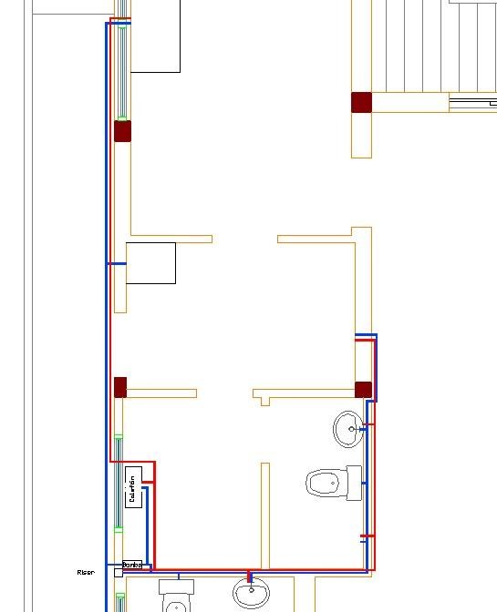

Figure 6.Grown floor layput

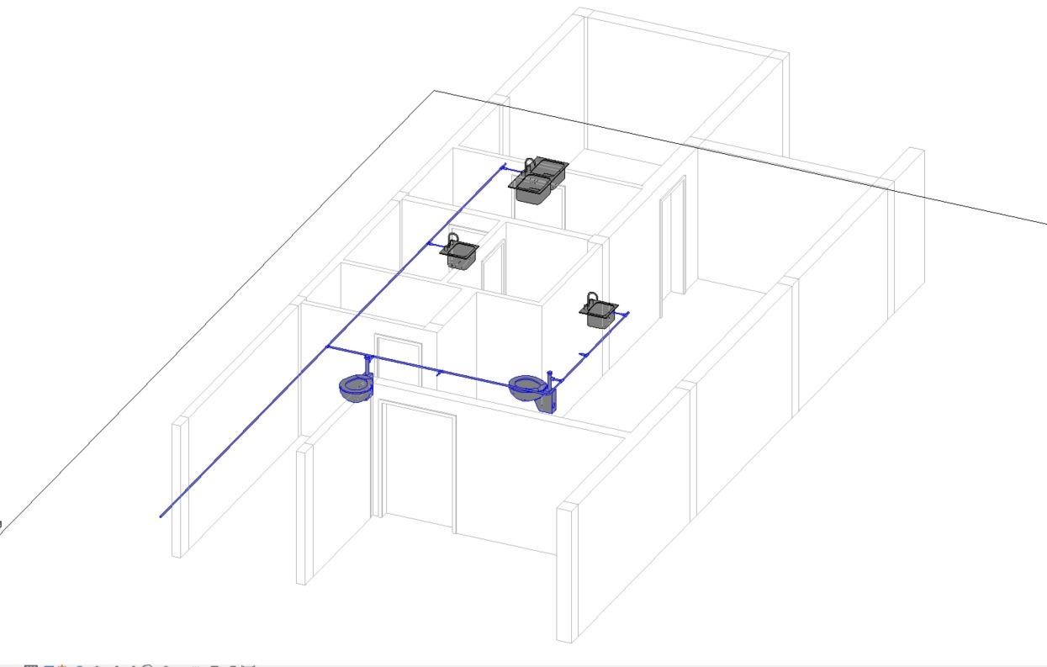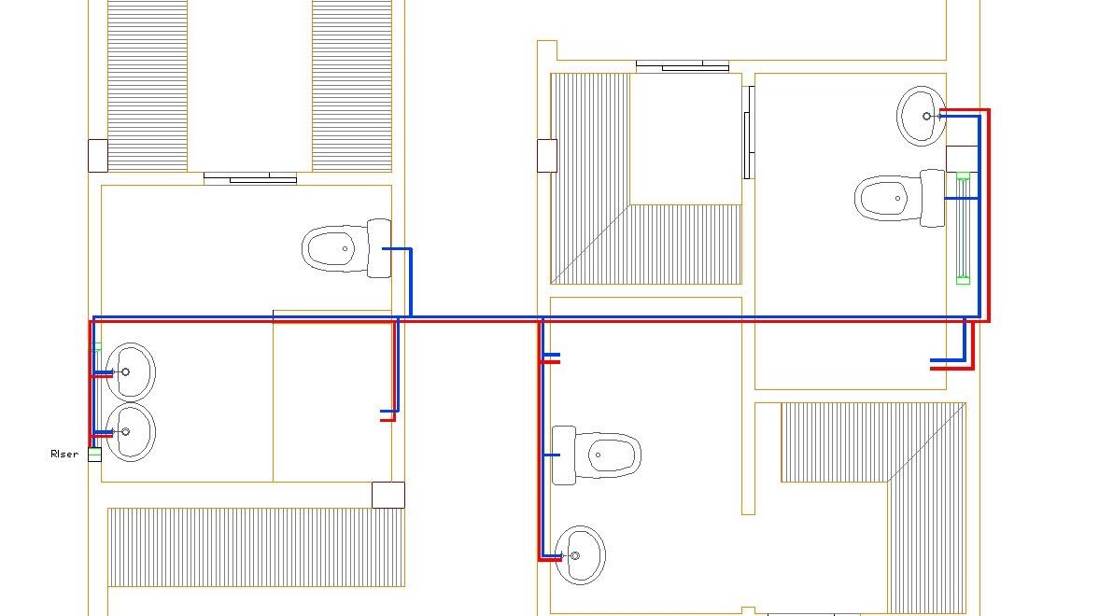

Figure 7. Isometric view

Figure 8. Upper floor layout.

## ***2.6 Pumping systems***

For this, it is necessary to know the dimensions of all the pipes that are connected to the plumbing fixtures that supply water to the house to determine the most appropriate pump model. It is also necessary to know the flow rates that INEN 11-16 regulations recommend to start the design of the pump.

**Suction**

According to the calculations we take out, it was obtained that:

Now we got:

|  |  |  |  |  |  |  |
| --- | --- | --- | --- | --- | --- | --- |
| Bomba | 2.4 | 15 | 0.267 | 0.64 | 45.14 | 1 1/2'' |

Finally, to select a bomb we use the curves table of Pedrollo’s Pumps.

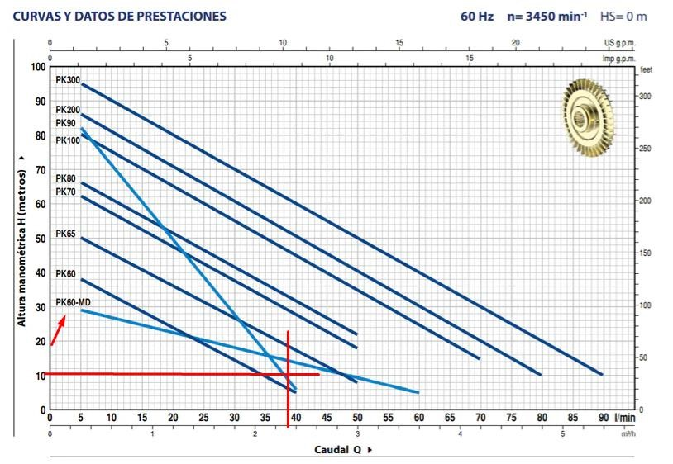

Figure 9. Pedrollo’s curves for pump.

According to the table of Pedrollo’s pumps, we select the model PK60-MD with a power of

0.5HP of 110 volts V. Monofase.

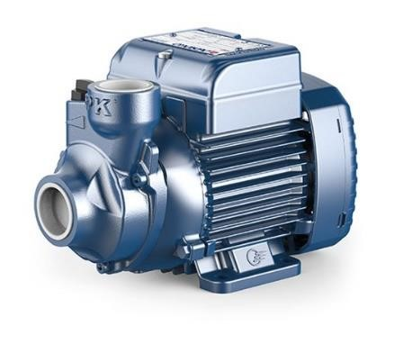

Figure 10. PK60-MD Model pump

## ***2.7 Technical specifications: Drinking water systems***

**Item:** SUPPLY AND INSTALLATION OF PVC PIPE 1” **Unit:** m

**Design Criteria**

The supply and installation of polyvinyl chloride (PVC) pipes and accessories for drinking water of the different size 1”, will be understood as the set of operations that the Builder must execute to supply and place in the places indicated by the project and/or the orders of the Construction Supervising Engineer, the pipes and accessories required in the construction of the Drinking Water network.

**Installation Procedure**

The supply and installation of PVC pipes and accessories includes the following activities: the supply and transportation of the pipe and accessories to the place of their placement or temporary storage; the local maneuvers and transportation that the Builder must do to distribute it to the installation sites with the respective couplings, and the testing of the pipes and accessories already installed.

PVC pipes and fittings manufactured for threaded joints will meet at least the following specifications:

* **Pipe**

**Material:** Rigid PVC (polyvinyl chloride)

**Union type:** Threaded

**Specification:** ASTM D-1785

**Thread type:** American standard (NPT) according to ANSI B standard

2.1; INEN 2497

* **Accessories**

**Material:** PVC (polyvinyl chloride)

**Type:** Reinforced

**Specification:** ASTM D-2464

**Joint Type:** Female Threaded

**Thread type:** American standard (NPT) according to ANSI B standard

2.1; INEN 2497

* **Packaging**

For threaded joints, exclusively Teflon tape and thread seal will be used.

* Prior to installing the pipe and accessories, they must be clean of dirt, excess paint, oil, dust, or any other material found inside or on the exterior faces of the ends of the tubes that will be inserted into the joints. corresponding.
* The required cuts in the tubes will be made at right angles to their longitudinal axis, rendering their interior section to the correct diameter, free of all burrs.
* Bending the tubes will not be allowed, appropriate accessories will always be used.
* For all coupling of pipes with valves and accessories using threads, Teflon tape and thread seal will be used.
* Before proceeding to seal the pipes, the system must be tested partially or as a whole, injecting water up to a pressure of no less than 100 PSI, the test will be done according to the standardized method.
* In the presence of water leaks, the pipe will be repaired and retested.
* When installing the pipes and accessories, special care must be taken to ensure that water or any other substance that contaminates the interior parts of the pipes and joints does not penetrate inside.
* When there are interruptions in work, or at the end of each workday, the open ends of the pipes and accessories whose installation has not been completed must be covered, so that foreign materials, dirt, garbage, etc. cannot penetrate inside.

**Threaded joints:**

Plastic pipe with sufficient wall thickness may have threaded joints with coupling for each tube, according to ASTM 1785. Before making the joint, the threaded sections of the tube and coupling must be cleaned with solvent in order to eliminate all traces of grease and dirt.

**Form of payment**

The installation of pressure PVC pipes with threaded union will be measured by linear meters and will be paid per meter actually installed, including coupling accessories such as universal unions, elbows, tees, etc.

**Item:** DRINKING WATER ACCESSORIES **Unit:** Unit (u)

**Design Criteria**

The function of stopcocks and valves is to control the flow of water through a supply pipe to a sanitary service or a group of them.

**Installation Procedure**

General review of plans with location of the stopcocks to be installed and the type of key; A distinction must be made between bell-shaped and cross-head shut-off valves, whether they are installed in an interior environment (such as a bathroom) and whether they are visible or hidden inside a piece of furniture. Likewise, a stopcock with threaded ends will be available, or smooth ends if they are for a welded joint. The chosen stopcock must fulfill the function required on site. The builder will present reports of compliance with these specifications, samples taken from the material used on site, or in turn the manufacturer's certificates or what is determined by the inspection.

* Check that the place where a stopcock or valve is installed is accessible for its operation and that it does not interfere with the location of furniture.
* The installation of the stopcock or valve will be in the exact location, to facilitate its maneuverability as well as its eventual repair or maintenance; Excessive adjustments that could break the key will not be made.
* When installing a stopcock or valve with threaded joints, Teflon tape will be used as a sealant.
* Before proceeding to seal the installation, it will be subjected to a pressure test. If water leaks are observed, the corresponding repair will be made, and a new test will be carried out.

**Form of payment**

The placement and installation of accessories will be paid e unit prices stipulated in the UPA.

**Item:** PVC WATER OUTLET 1/2" **Unit:** Unit (u)

**Design Criteria**

The construction of a network of pipes for drinking water aims to end in one or more outlets, known as "Water Point" in the diameters established in plans, from which service is provided to a sanitary device or water intake for different purposes. use; The material to be used is PVC pressure threaded union.

**Installation Procedure**

* The installation process will begin at the connection point of each room, using a universal pipe, then installing the pipes that run to the bathroom rooms or service areas, to conclude with the location of the water points in these areas.
* For threading, the appropriate die for PVC pipe will be used with the die and guide that corresponds to the diameter of the pipe with the NPT thread specification; The threading will be carried out in a single continuous operation, without cutting the chip and returning the die; fillets must be precise and clean, as determined by ANSI B 2.1.
* Inspection will approve or reject the completed points, verifying compliance with this specification, the results of material and water pressure tests and the total execution of the work.
* The water point includes the accessories and the vertical section of pipe that is derived from the distribution pipe.

**Form of payment**

The measurement will be made by threadable PVC water point.

|  |  |
| --- | --- |
| PUBLIC NETWORK CONNECTION 3/4"(INCLUDES | |
| ACCESSORIES +METER) |  |

**Item:** **Unit (u)**

**Design Criteria**

The installation of home connections in occupied lots and in empty lots will be understood as the set of operations that the contractor must carry out, in order to connect to the pipes of the public drinking water distribution network, using pipes and special pieces. Such operations include the installation of collars, pipes, fittings, connecting parts.

**Installation Procedure**

* Home connections will be defined by the nominal diameter of the connection pipe.
* In the distribution network pipe (PE, PVC, ductile iron, steel, fiber cement), a ductile iron bypass collar will be installed. The collar will be highly resistant to the forces caused by ground movements, with minimal epoxy coating. 120 microns with rubber sealing gasket, dichromate galvanized steel screws (the sealing gasket will comply with Standard EN 681.1 or equivalent and must be suitable for a temperature of up to 40 degrees Celsius). A torque wrench will be used to allow proper adjustment of the collar.
* The inlet will be a gas type thread, the outlet will have a brass compression link for HDPE tube. The tightness test of the body and the plug will be in accordance with Standard ISO 5208 or equivalent, as well as the link test with Standard ISO 3458, 3459, 3501 and 3503 or equivalent.
* Once the insertion key is installed, the drilling will proceed, using appropriate tools and equipment.
* It should be carefully bent to form the goose neck, avoiding breaks, deformations and strangulation.
* The meter must be installed in a place accessible for reading, assembly, maintenance, removal or for dismantling the mechanism on site if necessary. Likewise, care must be taken to place it in a properly illuminated place and the floor must be free of obstacles, rigid, uniform and not slippery.
* The meter will be placed perfectly aligned and level to avoid damage to the threads and water leaks. The fixation of adjacent accessories must be carried out avoiding forcing the threads in the fit with the meter and if necessary, the meter will be mounted on bases or supports. For the installation of the meter, the minimum separation that must exist between it and any upstream or downstream accessory must be taken into account.
* The box must be placed on a well-compacted and approximately horizontal surface and must be at the level of the sidewalk. The pipe will be cleaned before placing the meter.
* The meter will be placed in a perfectly horizontal position (upper face of the totalizer horizontal and directed upwards).
* In the case of tilting against a wall, the counter may tilt slightly or completely.
* The body of the meter is provided with two pipes with standardized threads for connection. To avoid damaging the sealing gasket, do not exceed the maximum tightening torque of 30 mN.
* The cut-off key will be opened initially, and then the control key will be opened very gently so as not to damage the meter.
* The proper functioning of the meter will be verified, and the absence of leaks in the meter - property section. If any anomaly is detected, it will be reported immediately to the construction inspector.
* The meter, accessories and box will be left perfectly clean.
* If possible, the site will be left in a condition similar to the conditions found.
* Single jet meters have good sensitivity, with starting flow rates from 10 liters to 25 liters. With a useful life of 10 years.
* If it is in charged water, the meter propeller is not sensitive to suspended solids, lime or sedimentation.

**Form of payment**

The measurement for payment of this item will be the unit (u) of supply and installation of home connections and installation of the ½” meter.

### ***2.7.1 Piping***

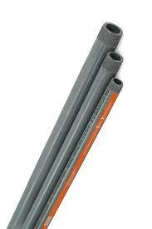For our cold-water pipe network, PVC pipes will be used:

The following table details the diameters used in the project.

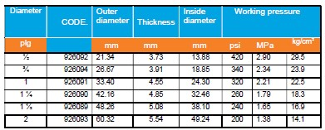

***General compliance standard:***

NTE INEN 2479

INEN 117:2013 ***General technical characteristics*** Length: 6 meters.

***Thread specifications:***

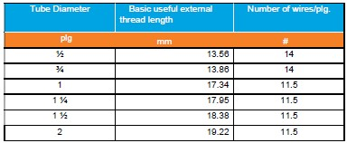

**Unit prices:**

|  |  |
| --- | --- |
| **Diameter** | **Price** |
| ½” | $6,25 |
| ¾” | $9,17 |
| 1” | $16,51 |

Single layer gold line tube for hot water.

***General compliance standard:***

NTE INEN 2955

***General technical characteristics:***

Material: Polypropylene

Thickness: 3.4mm; 3.9 mm; 4.9 mm. • Working Pressure: 1.00 MPa temperature 20°C

Length: 6 meters.

***Unit prices:***

|  |  |
| --- | --- |
| Diameter | Price |
| ½” | $10,98 |
| ¾” | $16,87 |
| 1” | $25,87 |

***General technical characteristics:***

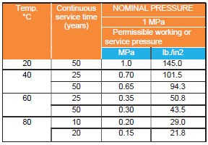

### ***2.7.2 Fittings (Elbows, tees, whys and reducers)***

***Tee***

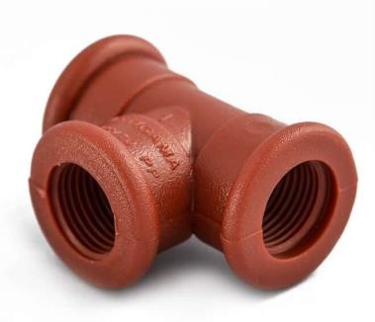

***Available diameters:***

½”

¾”

1”

1 ½”

2”

***General compliance standard:***

NTE INEN 2956

NTE INEN 1369

***General technical characteristics:***

Material: PPR (Polypropylene Copolymer Random) • Resistant to corrosion and oxidation.

Flexible materials for easy installation and transport.

Low thermal conductivity. ***Unit prices:*** $0,58 ***Applications:***

For cold and hot water supply up to 95°C, hotels, residential and service installations. ***Threaded Union HH***

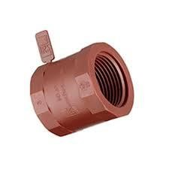

***Available diameters:***

½”

¾”

1”

1 ½”

2”

***General compliance standard:***

NTE INEN 2956

NTE INEN 1373

NTE INEN 2497

***Description:***

A connection used to join pipe to a threaded fitting, such as a filter or air valve.

***General technical characteristics:***

Material: PPR (Polypropylene Copolymer Random) • Resistant to corrosion and oxidation.

Flexible materials for easy installation and transport.

Low thermal conductivity.

***Unit prices:*** $0,55 ***Applications:***

For cold and hot water supply up to 95°C, hotels, residential and service installations. ***Threaded Union HH***

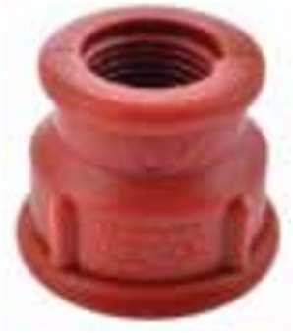

***Available diameters:***

½”

¾”

1”

1 ½”

2”

***General compliance standard:***

NTE INEN 2956

***Description:***

This accessory allows you to connect pipes of various sizes, ideal for transition points in piping systems.

***General technical characteristics:***

Material: PPR (Polypropylene Copolymer Random)

Long service life

Low pressure drops.

High chemical resistance ***Unit prices:*** $1,16 ***Applications:***

For cold and hot water supply up to 95°C, hotels, residential and service installations.

***Threaded Union HH***

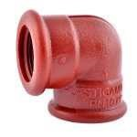

***Available diameters:***

¾” x ½”

1” x ¾”

1” x 1 ½”

***General compliance standard:***

NTE INEN 2956

NTE INEN 1328

***Description:***

A connection used to join pipe going in another direction with a fitting that has a thread.

***General technical characteristics:***

Material: PPR (Polypropylene Copolymer Random)

Long service life

Easy installation

It is used in cold and hot water • Low pressure drops.

High chemical resistance ***Unit prices:*** $0,49 ***Applications:***

For cold and hot water supply up to 95°C, hotels, residential and service installations.

### ***2.7.3 Valves (Breakdown in all their types)***

Brass gate valve

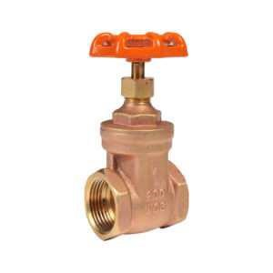

***Available diameters:***

½” @200PSI

¾” @200PSI

1” @200PSI

1 ½” @150PSI

2” @150PSI

2” @200PSI

3” @200PSI

4” @200PSI.

***General compliance standard:***

NTE INEN 116

NTE INEN 3027

***General technical characteristics:***

Material: Bronze

For water control in both hot and cold-water systems

NPT thread in all sizes

Range from ½” to 4” for 200 WOG and 1 ½” and 2” for 150 WOGS ***Unit prices:*** $11.69 ***Applications:***

For aerial and irrigation systems.

Civil constructions for example: hotels, buildings, hospitals.

### ***2.7.4. Pumps***

*Pump PKM60-MD*

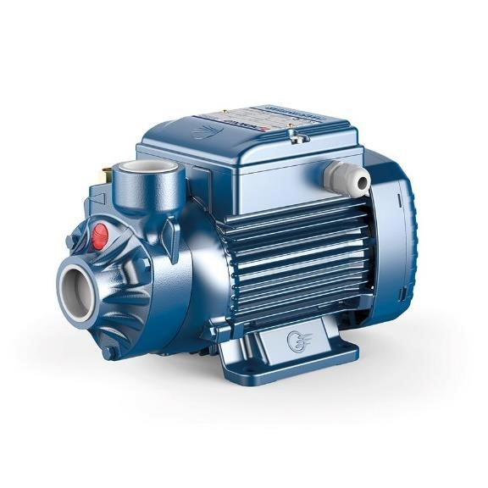

***Description***

They are recommended for pumping clean water, without abrasive particles and liquids that are not chemically aggressive with the materials that make up the pump.

Due to their reliability, simplicity of use and economic advantage, they are suitable for domestic use.

***General technical characteristics:***

Power: 0.5 HP

Voltage: 110 V. Single phases

Suction: 1

Discharge (inch): 1

Flow rate (maximum): 60 lpm • Height (maximum): 29 m.

***Applications:*** Domestic, industrial.

***Unit prices:*** $135.0***Chapter 2: Sanitary drainage system***

* 1. ***Sanitary drainage system***

### ***3.1.1 Description***

It is the type of water thar is produced by the human consumption, domestic waste and is classified as gray/black water. This type of water generates gases that must be carried to a place where people cannot smell it.

The house for this project takes with two floors, the same that will discharge wastewater into the sanitary system.

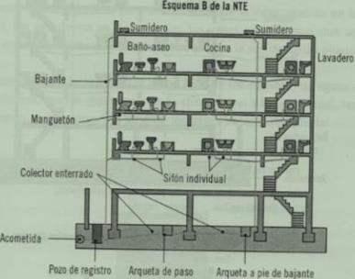

Figure 11. Design of the drainage pipes

**Design criteria**

* It must be ensured that there is no stagnation of wastewater, thus, the evacuation will be fast and efficient.
* Prevent microorganisms and bad odors from entering the living environment of the dwelling.
* Ensure that the design of the drainage pipes is in accordance with the NEC requirements.
* The minimum slope that should exist in the pipes is 1%, however, the range is 3% - 15%. • The minimum diameter of the trap of each pipe must be 50 mm.
* For inspection boxes located outside the house, the minimum distance should be every 30 meters.
* For pipe branches, diameters and slopes must be in accordance with the DFU drainage fixture unit.

***3.1.2 Diameter of downspouts/downpipes***

|  |  |  |  |
| --- | --- | --- | --- |
|  | **Class** | **DMD** | **UEH** |
| WC | 1 | 100 | 3 |
| WC | 2 | 100 | 5 |
| WC | 3 | 100 | 6 |
| Lavatory | 1 | 38 | 1 |
| Lavatory | 2 y 3 | 38 | 2 |
| Bathtub | 1 | 50 | 3 |
| Ina Bathroom | 2 y 3 | 50 | 4 |
| Lluia Bathroom | 1 | 40 | 2 |
| Bathroom Lluia multiple /m | 2 y 3 | 50 | 6 |
| Bidet | 1 | 50 | 1 |
| Bidet | 2 y 4 | 50 | 2 |
| Urinal | 2 y 3 | 38 | 1 |
| Pedestal urinal | 2 y 3 | 75 | 3 |
| Urinal with perforated pipe /m | 2 y 3 | 75 | 5 |
| Dishwasher with and without dishwasher | 1 y 2 | 50 | 3 |
| Restaurant dishwasher | 3 | 75 | 8 |
| Glasswasher | 1 | 50 | 3 |
| Glasswasher | 1 y 2 | 75 | 8 |
| Laundry rooms with or without washing machines | 1 | 50 | 3 |
| Laundry rooms with washing machines | 1 y 2 | 75 | 6 |
| Swimming pool with water jet | 1, 2 y 3 | 50 | 3 |

Table 14. Units by accesory

Limited by the following data containing the discharge diameter limits:

|  |  |
| --- | --- |
| Discharge diameter (mm) | Maximum UEH in the entire discharge |
| 50 | 18 |
| 75 | 48 |
| 100 | 240 |
| 125 | 540 |
| 150 | 960 |
| 200 | 2240 |
| 250 | 3000 |
| 300 | 4200 |

Table 15. Discharge diameter limits

In addition, when adding the fixture units of other rooms and downspouts, we will use the first columns, since our residence has less than 3 floors as can be seen in the following table:

|  |  |  |  |
| --- | --- | --- | --- |
| **Downspout** | | **More than 3 floors** | |
| 𝜙 | **Up to 3 floors** | **Total per downspout** | **Total per floor** |
| 3 | 30 | 60 | 16 |
| 4 | 240 | 500 | 90 |
| 6 | 960 | 1900 | 350 |
| 8 | 2200 | 3600 | 600 |
| 10 | 3800 | 5600 | 1000 |
| 12 | 6000 | 8400 | 1500 |

Table 16. Downspouts per floor.

Finally, the results fot each plant are:

|  |  |  |
| --- | --- | --- |
|  | ***TOP FLOOR*** |  |
| **Accessory** | **UEH** | **Diameter (mm)** |
|  | ***MASTER*** |  |
| WC | 3 | 110 |
| Lavatory | 2 | 50 |
| Rain bath | 2 | 75 |
| TOTAL | 7 | 110 |
|  | ***BATHROOM 1*** |  |
| WC | 3 | 50 |
| Lavatory | 2 | 50 |
| Rain bath | 2 | 50 |
| TOTAL | 7 | 110 |
|  | ***BATHROOM 2*** |  |
| WC | 3 | 50 |
| Lavatory | 2 | 50 |
| Rain bath | 2 | 50 |
| TOTAL | 7 | 110 |
|  | ***GROUND FLOOR*** |  |
| **Accessory** | **UEH** | **Diameter (mm)** |
|  | ***SERVICE BATHROOM*** |  |
| WC | 3 | 110 |
| Lavatory | 2 | 50 |
| Rain bath | 2 | 75 |
| TOTAL | 7 | 110 |
|  | ***GUEST BATHROOM*** |  |
| WC | 3 | 50 |
| Lavatory | 2 | 50 |
| Rain bath | 2 | 50 |
| TOTAL | 7 | 110 |
|  | ***LAUNDRY AND KITCHEN*** |  |
| Sink | 2 | 50 |
| Washing machine | 2 | 50 |
| Dishwasher | 2 | 50 |
| TOTAL | 6 | 110 |

Table 17. Diameter of downspouts by room.

|  |  |  |
| --- | --- | --- |
|  | ***Vertical branches*** |  |
| **Section** | **UD** | **Diameter** |
| Downspout 1 | 7 | 110 |
| Downspout 2 | 5 | 110 |
| Downspout 3 | 7 | 110 |

Table 18. Diameter for vertical branches.

### ***3.1.3 Diameter of horizontal branches***

Considering the capability in units for each collector to convey water through the drainage pipes, we refer to the following table:

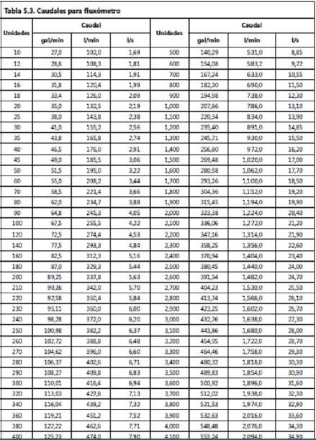

Figure 12. Flow rates per units.

The sections of the collectors are defined in the following plan:

|  |  |  |  |  |  |  |  |  |  |  |  |  |
| --- | --- | --- | --- | --- | --- | --- | --- | --- | --- | --- | --- | --- |
|  |  |  |  |  | ***TOP FLOOR*** | | |  |  |  |  | |
|  |  |  |  |  | Horizontal branches | | |  |  |  |  | |
| Section | UD | Diameter | Pending | Flow rates  (l/s) | Q/ Q0 | Y | Verification | V/ V0 | Full  Pipe  Speed | Actual Speed | Verification | |
| A-B | 7 | 110 | 1,5 | 1,69 | 0,177 | 0,325 | OK | 0,596 | 1,18 | 0,703 | OK | |
| E-F | 5 | 110 | 1,5 | 1,69 | 0,177 | 0,325 | OK | 0,596 | 1,18 | 0,703 | OK | |
| C-D | 7 | 110 | 1,5 | 1,69 | 0,177 | 0,325 | OK | 0,596 | 1,18 | 0,703 | OK | |
|  |  |  |  |  | ***GROUND FLOOR*** | | |  |  |  |  | |
|  |  |  |  |  | Horizontal branches | | |  |  |  |  | |
| Section | UD | Diameter | Pending | Flow rates  (l/s) | Q/ Q0 | Y | Verification | V/ V0 | Full  Pipe  Speed | Actual Speed | Verification | |
| G-H | 7 | 110 | 1,5 | 1,69 | 0,177 | 0,325 | OK | 0,596 | 1,18 | 0,703 | OK | |
| N-Ñ | 6 | 110 | 1,5 | 1,69 | 0,177 | 0,325 | OK | 0,596 | 1,18 | 0,703 | OK |
| L-M | 19 | 110 | 1,5 | 2,19 | 0,230 | 0,361 | OK | 0,664 | 1,18 | 0,784 | OK |
| I-J | 13 | 110 | 1,5 | 1,91 | 0,200 | 0,343 | OK | 0,645 | 1,18 | 0,761 | OK |
| K-O | 32 | 110 | 1,5 | 2,56 | 0,269 | 0,401 | OK | 0,707 | 1,18 | 0,834 | OK |
| P-Q | 39 | 110 | 1,5 | 2,91 | 0,305 | 0,432 | OK | 0,704 | 1,18 | 0,873 | OK |

Figure 13. Sections for the collectors in each floor

### ***3.1.4 Ventilation systems***

All venting systems were assumed with 2 inch diamter (50 mm).

|  |  |  |
| --- | --- | --- |
|  | **TOP FLOOR** |  |
| All | 50 mm | 2’’ |
|  | **GROUND FLOOR** |  |
| All | 50 mm | 2’’ |

Figure 14. Diameter for ventilation systems.

## ***3.2 Technical specifications: Sanitary drainage system***

**Piping**



Available diameters:

* 50 mm x 3 m
* 75 mm x 3 m
* 110 mm x 3 m • 160 mm x 3 m
* 200 mm x 6 m

General Compliance Standards:

-NTE INEN 1374

Description:

It is the system responsible for the drainage, sealing, and ventilation of sewage and rainwater in a building.

General Technical Characteristics:

Low coefficient of friction, higher efficiency

Smooth walls allowing for faster discharge.

Low weight, facilitating installation and transportation.

High impact resistance and flexibility Self-extinguishing, does not propagate flames.

Applications:

PVC pipes are used to connect sanitary fittings such as toilets, sinks, bathtubs, and showers. They provide a secure and watertight connection, preventing water leakage and ensuring efficient drainage.

Unit price: $8 - $10

**Elbow 45°**

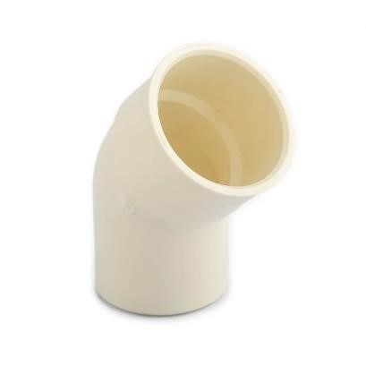

Available diameters: 50, 75, 110, 160, 200 mm

General Compliance Standards:

-NTE INEN 1374

Description:

It is a fitting used in sanitary water piping systems to change the direction of flow gradually at a 45degree angle. This type of elbow is designed specifically for plumbing applications and is used to connect pipe runs in a smooth bend rather than a sharp 90-degree bend.

General Technical Characteristics:

Low coefficient of friction, higher efficiency

Smooth walls allowing for faster discharge.

Low weight, facilitating installation and transportation.

High impact resistance and flexibility Self-extinguishing, does not propagate flames.

Applications:

They are used in drainage and sewerage systems to redirect the flow of wastewater efficiently by changing the direction of the pipe at a 45-degree angle. These elbows help minimize sediment buildup and clogging by maintaining a smooth flow and allowing proper movement of sanitary sewage throughout the piping system.

Unit price: $4 - $8

**Elbow 90°**

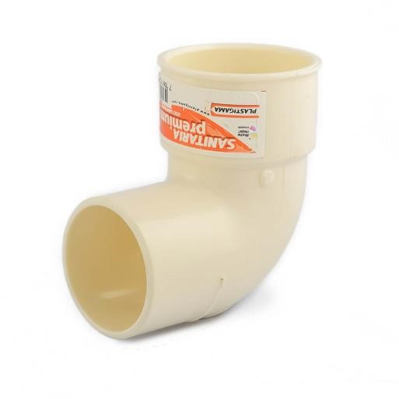

Available diameters: 50, 75, 110, 160, 200 mm

General Compliance Standards:

-NTE INEN 1374 Description:

A 90° sanitary elbow is a fitting used in sanitary water piping systems to change the direction of flow at a right angle of 90 degrees. This type of elbow is designed specifically for plumbing applications and is used to connect pipe runs in a sharp bend rather than a gradual curve.

General Technical Characteristics:

Low coefficient of friction, higher efficiency

Smooth walls allowing for faster discharge.

Low weight, facilitating installation and transportation.

High impact resistance and flexibility Self-extinguishing, does not propagate flames.

Applications:

They are used in drainage and sewerage systems to redirect wastewater flow at right angles. However, it is important to keep in mind that 90° bends can generate greater resistance to water flow compared to 45° bends, which can increase the risk of clogging and decrease the efficiency of the piping system. For this reason, it is recommended to avoid the excessive use of 90° bends in sanitary water systems and instead opt for more gradual bends when possible.

Unit price: $4 - $8

**Tee**



Available diameters: 50, 75, 110, 160 mm

General Compliance Standards:

-NTE INEN 1374 Description:

The PVC Yee is a pipe fitting used to join three pipes simultaneously in water distribution systems. It connects pipes at 45°-degree angles. It is lightweight. Limits fouling. It is the perfect union with PVC pipe, thus guaranteeing its watertightness.

General Technical Characteristics:

Low coefficient of friction, higher efficiency

Smooth walls allowing for faster discharge.

Low weight, facilitating installation and transportation.

High impact resistance and flexibility

Self-extinguishing, does not propagate flames.

Applications:

The Yee connection is used to interconnect three PVC sanitary pipes, orienting the 45° elbow downstream. This connection has the characteristic of being free and resistant to the pressures required to distribute the flow coming from the pipes connected to it. Unit price: $3 - $6

**Siphon**

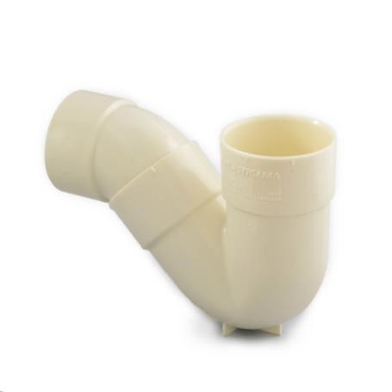

Available diameters: 50, 75, 110 mm

General Compliance Standards:

-NTE INEN 1374

Description:

The PVC siphon is a device used in plumbing and plumbing systems to prevent the backflow of unpleasant gases and odors from sewage pipes. It is made of PVC pipe, a strong and durable plastic material.

General Technical Characteristics:

Low coefficient of friction, higher efficiency

Smooth walls allowing for faster discharge.

Low weight, facilitating installation and transportation.

High impact resistance and flexibility Self-extinguishing, does not propagate flames.

Applications:

When a PVC trap is used in a sink, basin, shower or toilet, the water that accumulates in the trap acts as a trap, trapping unpleasant gases and odors and preventing them from being dispersed into the living environment.

The PVC trap is an essential part of the installation of plumbing and drainage systems in homes, buildings, and other structures, as it contributes to maintaining a hygienic environment free of undesirable odors. Unit price: $6 - $11

**Eccentric reducer**



Available diameters:

* 75 mm to 50 mm
* 110 mm to 50 mm
* 110 mm to 75 mm
* 200 mm to 160 mm

General Compliance Standards:

-NTE INEN 1374 Description:

A PVC eccentric reducer is a component used in PVC piping systems to facilitate the transition from one pipe diameter to another with different dimensions. Unlike a concentric reducer, which maintains a central alignment between pipes, the eccentric reducer provides an offset or off-center connection.

General Technical Characteristics:

Low coefficient of friction, higher efficiency

Smooth walls allowing for faster discharge.

Low weight, facilitating installation and transportation.

High impact resistance and flexibility Self-extinguishing, does not propagate flames.

Applications:

The PVC eccentric reducer has a conical or truncated cone shape, with a larger diameter end and a smaller diameter end. It is used to change the pipe size gradually, allowing a smooth flow and reducing the possibility of obstructions or turbulence in the system.

Unit price: $3 - $12

**Grid**

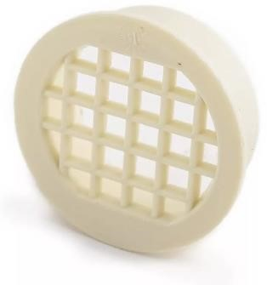

Available diameters: 50, 75, 110 mm

General Compliance Standards:

-NTE INEN 1374

Description:

It is used to allow the passage of air, water or light while retaining or protecting certain elements.

General Technical Characteristics:

Low coefficient of friction, higher efficiency

Smooth walls allowing for faster discharge.

Low weight, facilitating installation and transportation.

High impact resistance and flexibility Self-extinguishing, does not propagate flames.

Applications:

They are used in drainage systems to prevent clogging of pipes by allowing water to pass through while retaining larger debris.

Unit price: $5 - $8

**Liquid Welding**



Capacity: 20, 125, 250, 500, 946, 3785 cc

General Compliance Standards:

-NTE INEN 1374 Description:

Liquid welding for PVC is a method used to join PVC (polyvinyl chloride) pipe and fittings by applying a specialized adhesive. Unlike other joining methods, such as the use of threaded joints or couplings, liquid welding creates a permanent, watertight bond between the parts.

General Technical Characteristics:

Zero leakage" welded joint.

Wide use and application range (from 1/2″ to 6″).

Low VOC (volatile organic compounds) emissions.

Shelf life up to 3 years (properly stored).

Transparent color.

Applications:

It is important to follow the adhesive manufacturer's recommendations and guidelines to ensure proper application and to obtain a solid and durable bond. In addition, it is essential to work in a well-ventilated area and take proper precautions to avoid direct exposure to the adhesive, as it can be toxic. Unit price: $50

**Sanitary domiciliary box**



High: 250, 320, 400, 470 mm

General Compliance Standards:

-NTE INEN 1374 Description:

A sanitary junction box, also known as a sanitary inspection box, is a component used in sewer and drainage systems in residential buildings. This box is usually located on the outside of a house, near the main entrance, and is intended to allow access to the sewer network and to perform inspections, cleaning, and maintenance.

The sanitary junction box is designed as a rectangular or square structure, usually made of durable and resistant materials, such as concrete or PVC. It is usually equipped with a removable cover or lid that provides access to the inside of the box.

General Technical Characteristics:

Low coefficient of friction, higher efficiency

Smooth walls allowing for faster discharge.

Low weight, facilitating installation and transportation.

High impact resistance and flexibility Self-extinguishing, does not propagate flames.

Applications:

Inside the sanitary junction box are the connections and branches of the drainage pipes of the house, as well as the connections to the main sewerage system. These connections are usually properly sealed to prevent leaks and seepage.

The sanitary junction box allows plumbing professionals to perform visual inspections, unblock blockages or perform maintenance on the sewer mains, without the need to access the interior of the home. It also provides an access point for connecting or disconnecting additional piping in the event of modifications or extensions to the sewer system.

Unit price: $40 -$70

1. ***Chapter 3: Storm water drainage system***

## ***4.1 Storm water drainage system***

### ***4.1.1) Diameter of downspouts/downpipes***

Guayaquil’s city normally has an annual rainfall of 1750 mm, but, studies must be conducted to witness by the phenomenon of “El Niño”, for academic resources a rainfall of 100 mm per hour will be taken.

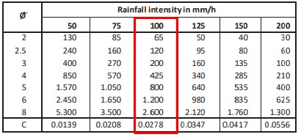

Table 19. Rainfall intensity

|  |  |  |  |  |  |  |  |  |
| --- | --- | --- | --- | --- | --- | --- | --- | --- |
| storm water donspouts | Área | | | Flow rate | Dimension | | Elevation | |
| Self | Accum | Max. | Q | L | Ø | Inicial | Final |
| m2 | m2 | m2 | lts/s | m | inch | m | m |
| A1 | 40.01 | 65 | 1.11 | 3.1 | 2" | 6.83 | 3.43 |
| 45 | 65 | 1.25 | 3.25 | 2" | 3.43 | -0.2 |
| A2 | 38.6 | 65 | 1.07 | 3.1 | 2" | 6.83 | 3.43 |
| 38.6 | 65 | 1.07 | 3.25 | 2" | 3.43 | -0.2 |

Table 20. Storm water downspouts

### ***4.1.2 Diameter of horizontal branches***



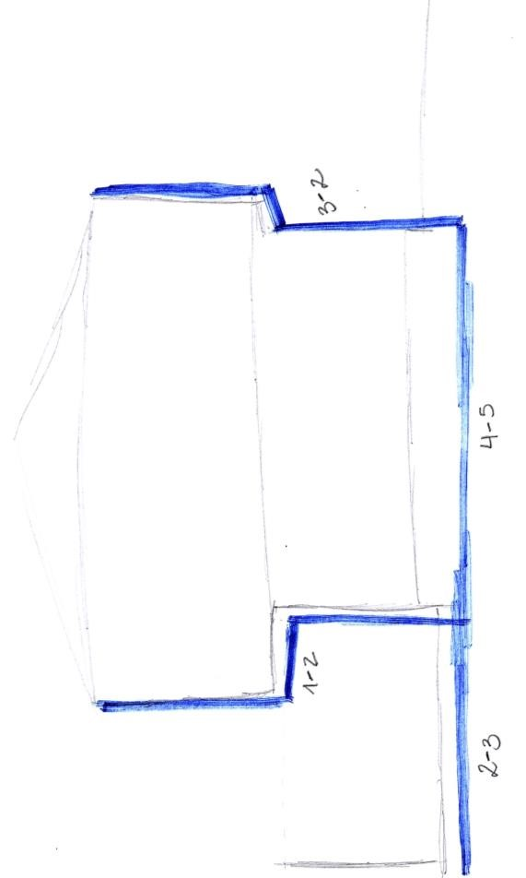

Figure 15. Area to drain

Figure 16. Paper versión. Rainwater schemes

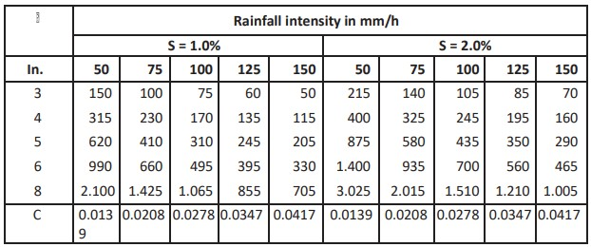

Table 21. Rainfall intensity by S %

|  |  |  |  |  |  |  |  |  |  |  |  |  |  |  |
| --- | --- | --- | --- | --- | --- | --- | --- | --- | --- | --- | --- | --- | --- | --- |
| storm water collector |  | Área |  | Flow rate | Dimension | | slope |  | Desing | |  | elevation | | |
| Self |  | Accum | Max. | Q | L | Ø | s | Qo | Vo | Vreal | Δh | Inicial | Final |
| m2 |  | m2 | m2 | lts/s | m | inch | % | l/s | m/s | m/s | m | m | m |
| A1 | Canalon | 40.01 | 75 | 1.1123 |  | 3" | 1 | 3.61 | 0.79 | 0.6 | 0.06 | 6.89 | 6.83 |
| Collector  1-2 | 40.01 | 75 | 1.1123 | 2.35 | 3" | 1 | 3.61 | 0.79 | 0.6 | 0.06 | 3.25 | 3.19 |
| Collector  2-3 | 83.58 | 170 | 2.3235 | 17 | 4" | 1 | 7.78 | 0.96 | 0.7 | 0.06 | -0.30 | -0.36 |
| A2 | Canalon | 38.6 | 75 | 1.0731 |  | 3" | 1 | 3.61 | 0.79 | 0.6 | 0.06 | 6.89 | 6.83 |
| Collector  3-4 | 38.6 | 75 | 1.0731 | 0.5 | 3" | 1 | 3.61 | 0.79 | 0.6 | 0.06 | 3.25 | 3.19 |
| Collector  4-5 | 38.6 | 75 | 1.0731 | 10.25 | 3" | 1 | 3.61 | 0.79 | 0.6 | 0.06 | -0.20 | -0.26 |

Tabla 22. Dimensions of storm water collectors

## ***4.2 Technical specifications: Storm water drainage system***

**Collectors:**

They are responsible for the collection of water from roofs and lead to the downspouts.

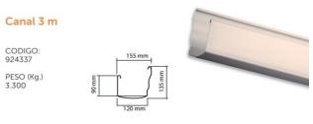

**Other accessories used are:**

* Unions in the corners • Unions between collectors
* Collector supports.
* Interior and exterior covers

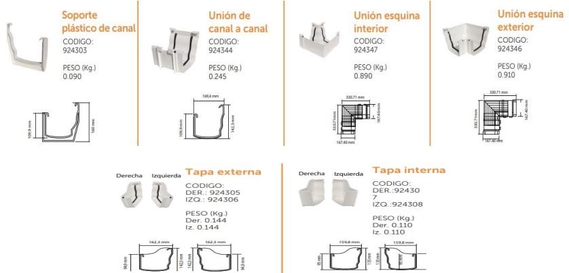

**Installation Process:**

1. Check if the deck is level.
2. The slope is marked.
3. The first support is placed.
4. The union between the collector and the downspout is placed.
5. There is roped to place the other supports level
6. The collectors are placed.
7. Inside or outside corners are placed.
8. The couplings of the covers
9. The collectors are joined with the downspouts by means of unions.

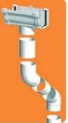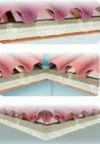

**Units:** Inches

Payments will be made in accordance with the terms of the contract, considering the unit price of each material, tools, transportation, etc., for the proper execution of the project.

For the correct execution of the project.

**Downspouts:**

The downspouts are responsible for transporting rainwater from the gutters to the curb or rainwater box.

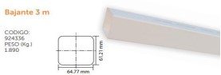

**Other fittings used are:**

-Downspout and sewer connection

-Elbows

-Downspout supports

-Unions

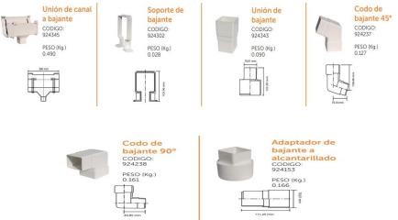

**Installation:**

1. Join the collector channel with the downspout by means of a union.
2. Connect the downspout to each other up to the lower level, it is recommended to support the downspout to the wall.
3. Connect the downspout to the sewer, using the adapter.

**System diagram**

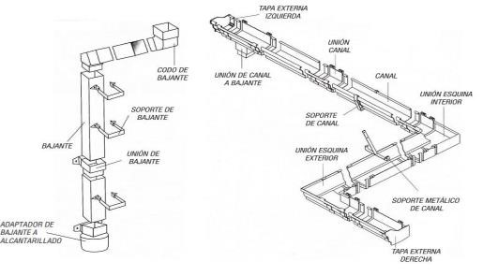

**Characteristics:**

-They allow the evacuation of large volumes of rainwater.

-They can evacuate a maximum of 90 m2 per downspout.

-Materials resistant to climatic and inclement weather.

-Texture that facilitates the internal self-cleaning avoiding obstruction or clogging.

-Their joints fit together perfectly.

-They can be painted.

**Pipes**

The pipes are used to collect, conduct, and evacuate wastewater and rainwater from homes and buildings. The downspouts are usually made of PVC material.



**Installation process:**

1. Cut the pipe at 90 degrees.
2. Sand the surface of the pipe where the cut was made, this in order to remove lumps and traces left by the saw.
3. When the joint is made, it is important to sand the surface before joining the pipes.

Then place the glue and position the pipes correctly.

1. To apply the glue, use a natural bristle brush.
2. Attach the smooth end of the pipe to the bell of the other pipe or fitting, making sure of a good coupling and holding firmly for 30 seconds. Remove excess weld seam and leave weld seam only between the ends to be joined.

**Advantages:**

-Increased impact resistance

-Smooth interior pipes, avoiding clogging.

-Allows the free flow of water with very small slopes, thus ensuring that there are no blockages. With correct practice, this installation process turns out to be very fast and simple. Always follow the manufacturer's recommendations.

1. ***Chapter 4: Electrical system***

## ***5.1 Estimation of the electrical demand***

The house has an area of 220 m2 of construction divided in two levels:

* Upper level: Three bedrooms with their respective bathrooms.
* Lower level: Big yard, laundry, kitchen, garden, garage, maid’s room with bathroom, living room, half bathroom under the stairs.

|  |  |  |  |  |  |  |  |  |  |  |
| --- | --- | --- | --- | --- | --- | --- | --- | --- | --- | --- |
| **PANEL** | **No.** | **VOLTAJE** | | **POLOS** | | | **COND. ELEC.** | | **DUCTO** | |
| A1 | A-1 | 120 | | 1 | | | 1#14+N#14 THHN AWG | | 1/2" | |
| T-1 | 120 | | 1 | | | 1#14+N#14 THHN AWG | | 1/2" | |
| T-2 | 120 | | 1 | | | 1#14+N#14 THHN AWG | | 1/2" | |
| T-3 | 120 | | 1 | | | 1#14+N#14 THHN AWG | | 1/2" | |
| T-5 | 220 | | 2 | | | 2#10+N#12+T#14 THHN AWG | | 3/4" | |
| T-5 | 220 | | 2 | | | 2#10+N#12+T#14 THHN AWG | | 3/4" | |
| A2 | A-1 | 120 | | 1 | | | 1#14+N#14 THHN AWG | | 1/2" | |
| A-2 | 120 | | 1 | | | 1#14+N#14 THHN AWG | | 1/2" | |
| T-1 | 120 | | 1 | | | 1#14+N#14 THHN AWG | | 1/2" | |
| T-2 | 120 | | 1 | | | 1#14+N#14 THHN AWG | | 1/2" | |
| T-3 | 120 | | 1 | | | 2#10+N#12+T#14 THHN AWG | | 3/4" | |
| **PUNTOS** | **POTENCIA UNITARIA (WATTS)** | | **POTENCIA INSTALADA (WATTS)** | | | **FD** | | **DMU (WATTS)** | |
| 10 | 100 | | 1000 | | | 0.7 | | 700 | |
| 5 | 100 | | 500 | | | 0.8 | | 400 | |
| 2 | 250 | | 500 | | | 0.8 | | 400 | |
| 2 | 1500 | | 3000 | | | 1 | | 3000 | |
| 1 | 700 | | 700 | | | 1 | | 700 | |
| 1 | 2500 | | 2500 | | | 1 | | 2500 | |
| 9 | 100 | | 900 | | | 0.7 | | 630 | |
| 4 | 100 | | 400 | | | 0.7 | | 280 | |
| 6 | 250 | | 1500 | | | 0.8 | | 1200 | |
| 2 | 250 | | 500 | | | 0.8 | | 400 | |
| 1 | 2500 | | 2500 | | | 1 | | 2500 | |
| **SERVICIO** | | | | |
| ILUMINACIÓN PLANTA BAJA | | | | |
| TOMACORRIENTES SALA, COMEDOR Y BAÑO | | | | |
| TOMACORRIENTES COCINA | | | | |
| TOMACORRIENTES LAVANDERIA | | | | |
| TOMACORRIENTES BOMBA DE AGUA | | | | |
| TOMACORRIENTES A/C PLANTA BAJA | | | | |
| ILUMINACIÓN DORMITORIOS | | | | |
| ILUMINACIÓN PASILLO Y BODEGA | | | | |
| TOMACORRIENTES DORMITORIOS Y BAÑOS | | | | |
| TOMACORRIENTES PASILLO Y BODEGA | | | | |
| TOMACORRIENTES A/C MASTER | | | | |

|  |  |
| --- | --- |
| **Demanda Potencia (WATT)** | **12710** |

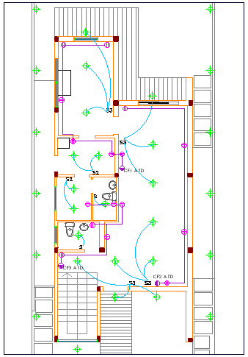

Figure 17. Ground floor – Electrical distribution

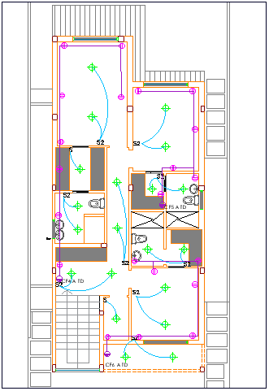

Figure 18. Upstairs – Electrical distribution

## ***5.2 Feeding system to transformer***

The electrical distribution is taken from distribution towers, transmission lines and transformation substations, composed of transformers, control and protection equipment. In Ecuador, electric power distribution is part of the National Transmission System, which consists of the set of electrical facilities comprising transmission lines, substations, and assets in general, which in turn is part of the National Interconnected System (SNI) and allows the transfer of electric power between generation centers and consumption centers, aimed at providing the public service of electricity supply.

**Distribution Transformers**

Distribution transformers convert the voltage of the primary distribution system to a desired lower value, which is known as the utilization voltage. Those are located between the medium voltage primary feeders connected through a primary fuse, which is responsible for disconnecting in the event of failures or short circuit, and the secondary distribution system (branch circuit), which may also be protected by a fuse or by secondary circuit breakers.

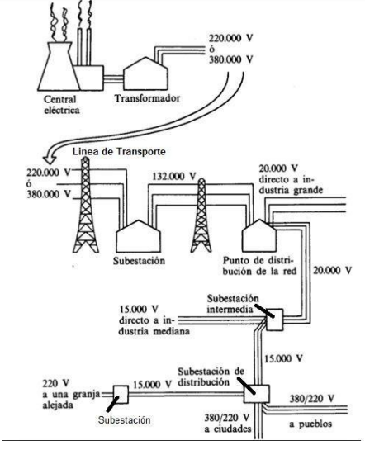

Figure 19. Distribution Transformers example

The type of transformer depends on its location, among the most common for this application are the submersible, pole type and pad mounted transformers installed outdoors and come with standardized demands: 45 kVA, 75 kVA, 112.5 kVA, 150 kVA, 225 kVA, 300 kVA, 500 kVA, 750 kVA, 1000 kVA, 1500 kVA, 2000 kVA, 2500 kVA, 3000 kVA, 3750 kVA and 5000 kVA.

## ***5.3 Feeding to main panelboard (TDG)***

A cable is used inside a pipe that serves for protection and transfer the electrical energy. The distance between both points is approximately 2 meters that will pass through a 1¼ inch pipe that is embedded in the exterior wall formwork leading to the panelboard.

TopFlex H05V-K cable will be used because of the minimum size recommended for homes according to Ecuadorian Electrical Engineering Standards.

It is important to ensure that wiring and piping comply with Ecuadorian Electrical Standards and Regulations to guarantee a safe and reliable installation.

## ***5.4 Panelboards***

The board intended for meters shall be of metallic nature adopting the shape of a cabinet or minimum box. Using 1.5 millimeters of thick sheet metal and coated with anticorrosive paint to conserve the product.

Inside the panel, we will find a socket outlet and space will be reserved for the 2P-100 A main switch. According to NATSIM guidelines, this device is installed on the pole using metal camps to secure it.

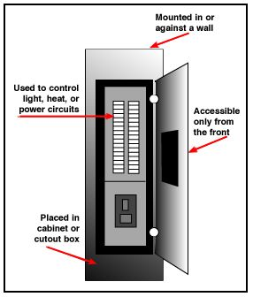

Figure 20. Panelboard distribution

## ***5.5 Feeding to distribution panelboards***

The feed to the distribution panels is carefully established based on their origin and specific location. From the meter to the PD-A distribution panel, a 1 1/4" pipe will be used. We will use the following items:

* Two #4-gauge phase wires
* A #4 wire for neutral and #8 wire for grounding.
* A 5/8" cooperweld rod with a length of 1.8 meters will be used to ensure proper grounding.
* As for the feed from the PD-A distribution panel to the PD-B distribution panel, 1" pipe will be used

Then, these components will be installed: t

* Two #8-gauge phase wires
* A #10 wire for neutral and a #12 wire for grounding.

These details have been carefully designed to ensure a safe and efficient electrical configuration in the branch circuits of each of the distribution panelboards involved.

Figure 21. “Unifilar” diagram

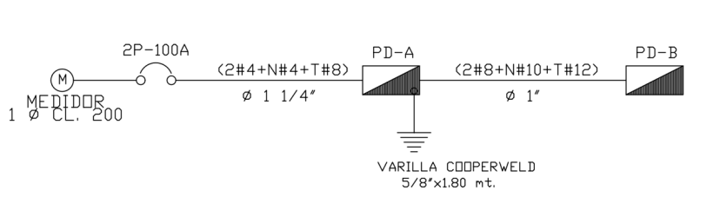

***5.6 Branch circuits***

Goes from the breaker panel to the building devices and is classified into appliance, individual or utility circuits, according to their function.

Generally, the most common circuits for homes are:

* Outlet circuits
* Lighting circuits
* Special (A/C, Heater, Ref., etc.)

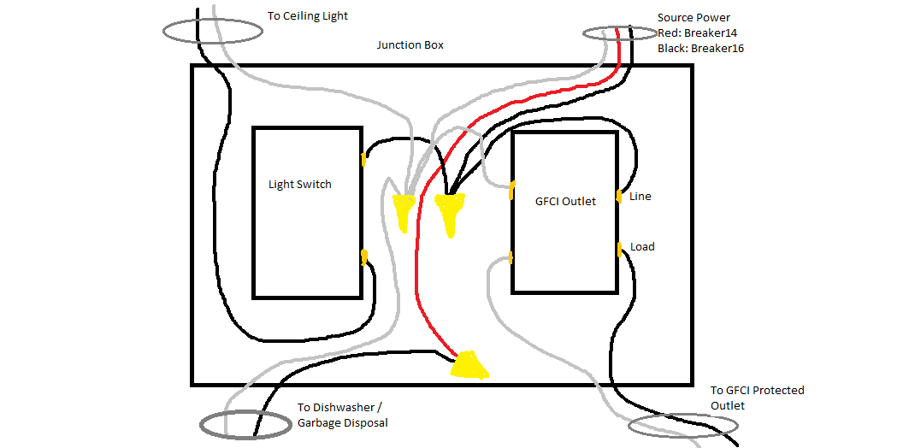

Figure 22. Branch circuits distribution

We have the circuit breakers in the electrical panel that protect the internal circuits of the installation. Then, to connect all the circuits to consumption points we have the branch circuits. This one comes from the main switchboard that brings all the power from a set of power cables from the energy meter.

We need a protection all the electrical circuits by using the breakers located in the panel. The circuits are classified accordin on maxium intensity of the breaker. The capacity goes from: 15, 20, 30, 40, 50 or 60 A for a singlue or double pole brakers.

|  |  |  |  |  |
| --- | --- | --- | --- | --- |
| **Capacidad del Braker (Monopolar)** | **Tensión** | **Potencia** | **Corriente segura** | **Potencia segura** |
| 15 | 120 | 1800 | 12 | 1440 |
| 20 | 120 | 2400 | 16 | 1920 |
| 30 | 120 | 3600 | 24 | 2880 |
| 40 | 120 | 4800 | 32 | 3840 |
| 50 | 120 | 6000 | 40 | 4800 |

Table 23. Monopolar Braker Capacity

|  |  |  |  |  |
| --- | --- | --- | --- | --- |
| **Capacidad del Braker (Bipolar)** | **Tensión** | **Potencia** | **Corriente segura** | **Potencia segura** |
| 20 | 240 | 4800 | 16 | 3840 |
| 30 | 240 | 7200 | 24 | 5760 |
| 40 | 240 | 9600 | 32 | 7680 |

Table 24. Bipolar Braker Capacity

Setting the capacity of protection devices, the maximum is 80% that can work.

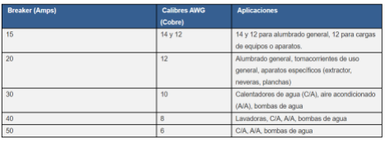

Table 25. Aplications by breaker

*Wiring:*

Attached to potential feeder busbars. Single pole breaker for 120 V circuits, in case of 240 circuits, a bipolar breaker is needed to protect it.

The breaker panel includes supports where the breakers are press-fitted. For the installation of the neutral and ground conductors, they are connected directly to the busbar and do not go through protection.

*Requirements:*

Depends on the INEN regulations approved. (Brand, type of conductor, manufacturers, etc.)

## ***5.7 Grounding systems***

*Grounding principles*

Physical connections between metallic parts of an electrical equipment and ground, limiting the voltage in the metallic parts of the equipment to prevent them from reaching dangerous values for the life of a human being.

Additionally, the grounding connection creates a low impedance path for current drainage in case of failure. The types of grounding are:

*Electrodes*

Collect or dissipate current to ground. Needs to be at ground level unless protected against physical damage. Iron or steel electrodes should have an outer galvanized surface with any other metal to protect against corrosion.

*Grid or ground grid*

A horizontal arrangement of interconnected electrodes that provides a common grounding point for electrical devices or metallic structures.

*Ground plate*

It consists of a solid sheet metal that is often placed in shallow locations on top of a ground grid or elsewhere on the surface, for obtaining an extra measure of protection by minimizing damage from exposure to high step and touch voltages in critical areas of operation or in areas that are frequently trafficked. A common form of grounding plate is a wire mesh placed directly under the crushed stone; each plate electrode should have a useful ground contact area of at least 0.2 m (1 ft). Iron or steel plate electrodes shall be at least 6 mm thick, while non-ferrous metal electrodes shall be at least 1.5 mm thick.

*Earth ring*

A grounding ring consists of a bare copper conductor not smaller than No. 2 gauge, not less than 6 m in length, buried in direct contact with the ground not less than 80 cm above ground level and surrounding the building or structure. Metallic gas pipes and aluminum electrodes are not allowed to be used as grounding electrodes.

## ***5.8 Branch circuit schedules***

The house has an area of 220 m2 of construction divided in two levels:

Figure 24. Electrical Distribution – Upstairs



Figure 23. Electrical Distribution – Ground Floor

|  |  |
| --- | --- |
| **Demanda Potencia (WATT)** | **12710** |

## ***5.9 Branch circuit schedules***

### ***5.9.1 Codes and standards used.***

The codes used for the design of the electrical system (all installations) are:

* NEC – Ecuadorian Construction Regulation: Electromechanical Installations
* NEC-SB-IE
* CPE INEN 019: National Electrical Code

### ***5.9.2 Materials***

|  |  |  |
| --- | --- | --- |
| **Article** | **Unit** | **Unit price ($)** |
| Conduit pipe 1’’ | m | 1.45 |
| ½'’ conduit pipe | m | 0.8 |
| ¾'’ conduit pipe | m | 0.9 |
| EMT ½'’ pipe (Installation included) | m | 2.5 |
| EMT ¾'’ pipe (Installation included) | m | 3.2 |
| Union EMT 1’’ (Accesories included) | U | 0.98 |
| Union EMT ¾'’ (Accesories included) | U | 0.9 |
| Breaker Plug 1P 40A TEKNO | U | 1.7 |
| Square PVC box 5x5 | U | 2.15 |
| PVC Octagonal box | U | 0.6 |
| Rectangular PVC box 10x4 | U | 0.75 |
| Switch 2V 15A | U | 1.60 |
| TEKNO Double 15A socket | U | 0.99 |
| Flexible cable AWG 10 roll 100 m | U | 86 |
| Flexible cable AWG 12 roll 100 m | U | 79.8 |
| Flexible cable AWG 14 roll 100 m | U | 53.1 |
| Flexible cable AWG 16 roll 100 m | U | 82 |

Table 26. Materials for each component

### ***5.9.2.1 Pipes***

The material of the pipes used for the electrical installations are made of PVC. It can be installed internally to the wall and fused into the piece.

|  |  |  |
| --- | --- | --- |
| **Pipe** | **Unit** | **Value per unit** |
| ½’’ Conduit PVC pipe | m | 0.35 USD |
| ¾’’ Conduit PVC pipe | m | 0.60 USD |
| 1’’ Conduit PVC pipe | m | 1.50 USD |

Table 27. Value per unit of pipes

**Installation**

We need to make sure of the following considerations.

* Pipe sections must be continuous between outlet boxes, junction boxes, panels, among others; and joined to the boxes by means of connectors, there must be mechanical solidity and electrical continuity in the installation.
* The piping must be embedded in the masonry carried by the ceiling, wall, or floor according to the design.
* Pipe sections should be secured with galvanized iron ties to the chains of the structure to prevent movement of the pipe during the concrete pouring process.
* The layout of the piping should preferably follow lines parallel to the vertical and horizontal lines where the installation is carried out.
* For ease of construction and/or maneuverability, try to install no more than two elbow fittings for the same length of pipe.
* The piping for the different lighting circuits, outlets and special outlets must be independent.

### ***5.9.2.2 Junction boxes***

It would be rectangular or octagonal and made of 1 mm pf thick galvanized steel. Each unit of boxes costs 2$ per unit.

**Installation**

* Suitably sized conduit boxes must be installed according to their size and the number of pipes that converge in them.
* Always leave enough space inside the junction box to allow for future access and inspection of connections. Do not overfill the box with cables or connections.
* Secure the junction box firmly and securely to the wall, ceiling or floor using appropriate fastening devices, such as screws or clamps. This will prevent the box from loosening over time and keep the connections in place.
* Place junction boxes in strategic locations according to your electrical design and functional needs. Make sure they are accessible and not obstructed by furniture, decoration, or any other element.

### ***5.9.2.3 Wire***

The project will utilize three cables from “Electrocables” of specifications THHN #12 copper #12 600V 90 °C. Among these, two cables are allocated for phase and one for neutral. Cable splicing will solely occur within junction boxes and splices, safeguarded by insulating pipes, not within pipes. The appropriate price of the cable stands at USD 0.90 per meter of length.

**Installation**

* Following the placement of conduits and junction boxes, the next step involves cable installation. These cables are threaded through the PVC pipes previously positioned, and it’s crucial to verify their accurate labeling.
* For extended conduit stretches, consider utilizing No. 16 galvanized wire to guide the cables through.
* Once in place, connect the cables to their designated devices. Be cautious not to overtighten the cables, as this could lead to inadvertent disconnection of devices.

### ***5.9.2.4 Panelboards***

A panelboard, also recognized as an electrical panel or distribution board, served as a vital element within a building´s electrical setup. Its key role involves efficiently channeling electricity from a central power source to diverse circuits or zones within the premises. Panelboards are crafted to organize and regulate the dispersion of electrical power in a secure manner. Typically, a panelboard comprises a metallic enclosure housing multiple switches or circuit breakers, witch act as protective mechanisms designed to halt electrical current flow in case of overloads or short circuits. Each switch or breaker governs a specific circuit and can be independently operated to enable or disable power flow. The unit price ranges $50-100.

**Installation**

* Prior to commencing any work, ensure the main power supply is deactivated and disconnected.
* Mount the panelboard at the designated location utilizing appropriate brackets.
* Establish connections between the power cables originating from the primary source and the panelboard, adhering to wiring standards and ensuring secure, proper linkages.
* Install circuit breakers onto the panelboard, ensuring their rating aligns with the circuit they safeguard.
* Connect individual circuit wires to their respective circuit breakers, ensuring accurate correspondence.

### ***5.9.2.5 Distribution panels***

The distribution panels within an electrical system of a project serve as central hubs for routing and managing electricity to various circuits or areas within a building or facility. These panels, also known as electrical distribution boards or breaker panels, are fundamental components that organize and control the flow of electrical power in a safe and efficient manner.

**Installation**

* Before installation, ensure that the location for the distribution panels aligns with safety regulations and accessibility requirements. Ensure a clear and properly ventilated space for installation.
* Position the distribution panel securely on the wall using appropriate brackets or mounts. Ensure that the mounting is level and stable.
* Connect the main power supply cables to the designated input terminals in the distribution panel according to the specified wiring standards and guidelines. Ensure that these connections are secure and follow proper safety protocols.
* Install circuit breakers or switches within the panel, allocating them to specific circuits or zones within the building. Each breaker is dedicated to controlling the flow of electricity to a particular area or device. Ensure the breakers are securely fitted and aligned within their designated spaces.
* Properly label each breaker to indicate its corresponding circuit or area it controls. Clear labeling facilitates easy identification and maintenance in the future.
* Perform a comprehensive check to ensure that all connections are secure and accurate. Test the functionality of each breaker by activating and deactivating them to confirm the expected operation.
* Once the installation and testing are completed satisfactorily, securely close the cover of the distribution panel and fasten all screws. Ensure that there are no exposed wires or loose connections.
* Restore power to the distribution panel from the main source after ensuring that everything is properly installed and verified.

### ***5.9.2.6 Circuit breakers***

The circuit breakers serve a dual purpose of safeguarding the electrical network by integrating with both the main panel and the meter. Moreover, individual breakers will be installed in each section of the main panel, specifically targeting areas like the first floor, upper floor, air conditioners, refrigerators, and sockets. The installation process for these circuits is simpler as they are integrated into the respective appliances or materials to be utilized.

The cost of each breaker stands at approximately $1.60 USD per unit.

**Installation**

* Begin by deactivating the power at the main distribution panel before undertaking any electrical tasks. This can be done by utilizing the main circuit breaker or shutting off the power at the source.
* Select the appropriate breakers tailored to the electrical load intended for connection. Refer to the distribution panel manual and specifications to determine the allowed types and sizes of breakers.
* Proceed to open the distribution panel cover following the manual's guidelines. Ensure the workspace is well illuminated and safe for operation.
* Identify any available slots or specified locations for new breakers within the panel. If needed, remove any covers obstructing these spaces.
* Insert the breakers into the assigned spaces, ensuring proper alignment of contacts. Confirm they securely snap into place.
* Wire the electrical connections to the breaker terminals in compliance with instructions and electrical codes. Employ suitable tools and ensure screws are tightly secured.
* Label each breaker indicating its corresponding function or circuit, facilitating future identification and maintenance.
* Before closing the panel cover, conduct tests to verify the proper functioning of the breakers. Confirm that connected devices operate as anticipated.
* Securely close the distribution panel cover and ensure all screws are tightened. Avoid loose wires or insecure connections.
* Following the installation and confirmation of proper functioning, reinstate power to the main panel.

### ***5.9.2.7 Switches and outlets***

Conventional switches will be placed at a height of 1.40 meters from the floor level near the doors, priced at $1.60 each. Additionally, commercial outlets will be installed at a height of 0.3 meters from the floor or at a suitable height for specific appliance connections, costing $1.00-1,20 each.

**Installation**

*Switches*

* Wire the electrical connections (usually a supply wire and a wire leading to the controlled device, like a light) to the switch following the manufacturer's instructions. Ensure proper stripping and secure connections.
* Install the switch into the junction box using provided screws. Confirm correct alignment and proper fitting of the faceplate.
* Activate power at the main panel and verify switch functionality by toggling the connected device on and off.

*Outlets*

* Connect the electrical cords (usually a supply cord and a cord for the device to be plugged in) to the outlet as per the manufacturer's guidelines. Ensure proper wire stripping and secure connections.
* Securely place the outlet into the junction box using provided screws. Confirm accurate alignment and proper faceplate fit.

### ***5.9.2.8 Transformers***

An electrical transformer modifies alternating current (AC) voltage in an electrical circuit. Its purpose is to increase or decrease voltage levels as required for electricity transmission, distribution, and utilization. Transformers play a vital role in electrical networks, enhancing the efficiency and safety of electricity transmission over varying distances.

Unit Price Range: $900 - $2000

**Installation**

* Position the transformer in its assigned location, ensuring level placement and proper fixation.
* Install bases or brackets as needed to securely hold the transformer in place.
* Connect transformer input and output wires to the respective power supplies and loads adhering to wiring standards.
* Ensure secure and proper connections, firmly tightening terminals.
* Ground the wires to designated points on the transformer, ensuring proper grounding.
* Before energizing the transformer, thoroughly inspect all connections for accuracy and security.
* Perform continuity and resistance tests to verify ground connections and other components.
* Once satisfied with the connections, power up the transformer, observing its initial operation.
* Monitor the transformer over time to ensure proper and expected performance, making adjustments if necessary to optimize its function.

1. ***Analysis of alternatives***
2. ***Recommendation and conclusions***
3. ***References***
4. ***Appendix***